MS Fabric
Contents
Introductions 2
Explore end-to-end analytics with Microsoft Fabric 2
Data teams and Microsoft Fabric 3
Enable and use Microsoft Fabric 3
Create Fabric enabled workspaces 4
Create items in Fabric 5
Explore Fabric workloads 6
Summary 7
Starting with LakeHouse in MS Fabric 7
Explore the Microsoft Fabric Lakehouse 7
Create and explore a lakehouse 8
Ingest data into a lakehouse 8
Practice 9
Ingest data until reporting using lakehouse 9
Use Apache Spark in Microsoft Fabric 9
Practice 9
Implement the lakehouse medaillon architecture IN MS Fabric 10
Structure the lakehouse (medaillon architecture bronze , silver , gold ) 10
Star modelling 10
Create semantic specific Model for gold layer 10
Monitoring Query’s 10
Implementation of warehouse in Fabric 11
Examen questions Example 11
Exam questions 13

Introductions
Fabric is an end to end data analytics platform that provides :
Capabilities like :
Ingest data
Store data
Process data
Analyse data

And the following services flatform
Data engineering
Data integration
Data warehousing
Real-time intelligence
Data science
Business intelligence

The learning mudules :
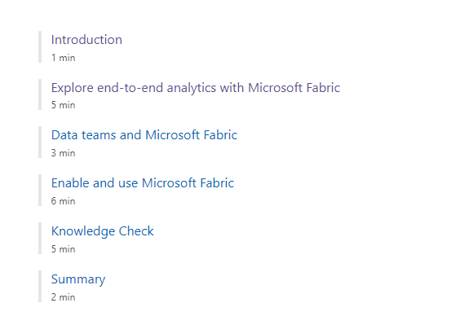

Explore end-to-end analytics with Microsoft Fabric
Fabric is a unified software-as-a-service (SaaS) with all your data stored in a single open format in OneLake.
Fabric's data warehousing, data engineering (Lakehouses and Notebooks), data integration (pipelines and dataflows), real-time intelligence, and Power BI all use OneLake as their native store without needing any extra configuration.
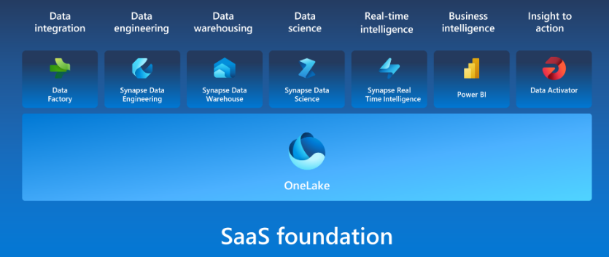

Fabric's experiences include:
- Synapse Data Engineering: data engineering with a Spark platform for data transformation at scale.
- Synapse Data Warehouse: data warehousing with industry-leading SQL performance and scale to support data use.
- Synapse Data Science: data science with Azure Machine Learning and Spark for model training and execution tracking in a scalable environment.
- Synapse Real-Time intelligence: real-time intelligence to query and analyze large volumes of data in real-time.
- Data Factory: data integration combining Power Query with the scale of Azure Data Factory to move and transform data.
- Power BI: business intelligence for translating data to decisions.

Data teams and Microsoft Fabric
For data analysts, who may have had to perform extensive downstream data transformations before creating Power BI reports, you can now see the lineage and connect with data more directly with DirectLake mode.

Enable and use Microsoft Fabric
If you have admin privileges, you can access the Admin center from the Settings menu in the upper right corner of the Power BI service. From here, you enable Fabric in the Tenant settings.
Admins can make Fabric available to either the entire organization or specific groups of users, who can be organized based on their Microsoft 365 or Microsoft Entra security groups. Admins can also delegate the ability to enable Fabric to other users, at the capacity level.
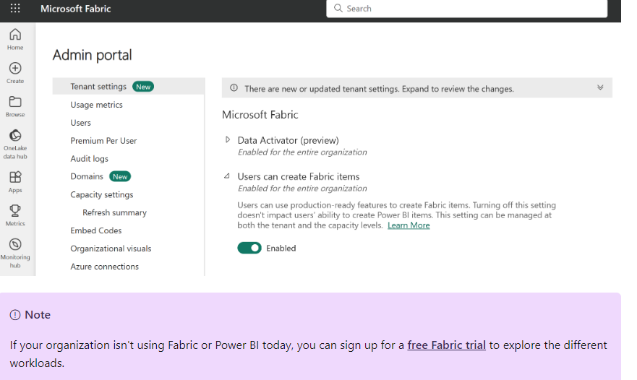

Create Fabric enabled workspaces
All Fabric items (lakehouses, notebooks, pipelines, etc.) are stored in OneLake and accessed via Fabric workspaces. To enable Fabric in a workspace, choose a Trial or Fabric Capacity license mode.
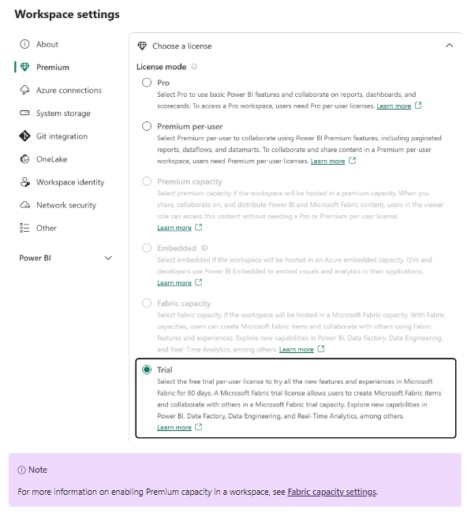

Create items in Fabric
After you create your Fabric enabled workspace, you can start creating items in Fabric. You can create items in Fabric using the Create menu in the upper left corner of the Power BI service

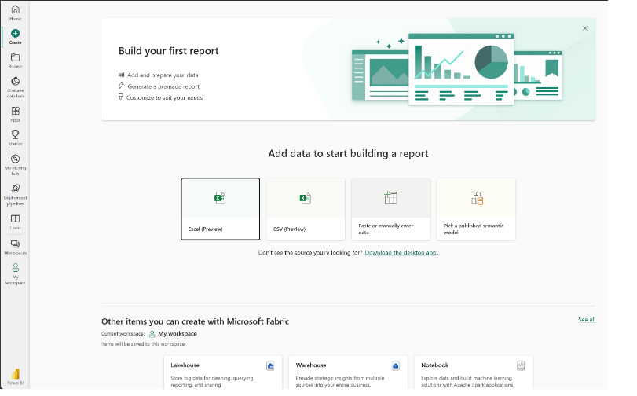

Explore Fabric workloads
Fabric workloads refer to the different capabilities included in Fabric. You can switch between workloads using the workload switcher in the bottom left corner of the navigation pane.
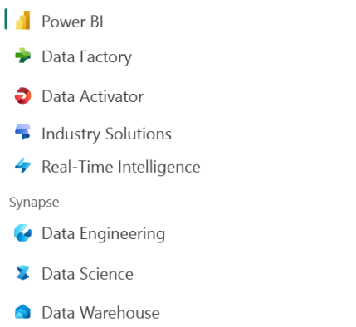
Note: You may notice that Fabric workloads look similar to other Microsoft data offerings. Fabric is built on Power BI and Azure Data Lake Storage, and includes capabilities from Azure Synapse Analytics, Azure Data Factory, Azure Databricks, and Azure Machine Learning. What makes Fabric unique is that it brings these capabilities together in a single, SaaS integrated experience without the need for access to Azure resources.

Summary
Data professionals are increasingly expected to be able to work with data at scale, and to be able to do so in a way that is secure, compliant, and cost-effective. At the same time, the business wants to use that data more effectively and quickly to make better decisions.
Microsoft Fabric is a collection of tools and services that enables organizations to do just that.

Starting with LakeHouse in MS Fabric
The foundation of Microsoft Fabric is a Lakehouse, which is built on top of the OneLake scalable storage layer and uses Apache Spark and SQL compute engines for big data processing

Explore the Microsoft Fabric Lakehouse
A Lakehouse is a great option if you want a scalable analytics solution that maintains data consistency. It's important to evaluate your specific requirements to determine which solution is the best fit.
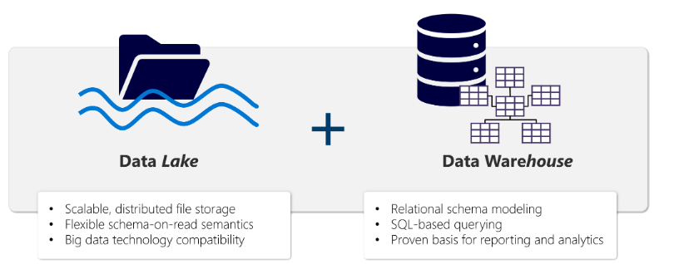
The Lakehouse Explorer enables you to browse files, folders, shortcuts, and tables; and view their contents within the Fabric platform.
After you've ingested the data into the Lakehouse, you can use Notebooks or Dataflows (Gen2) to explore and transform
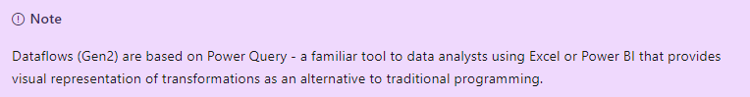

Create and explore a lakehouse
You create and configure a new Lakehouse in the Data Engineering workload. Each lakehouse produces three named items in the Fabric-enabled workspace:
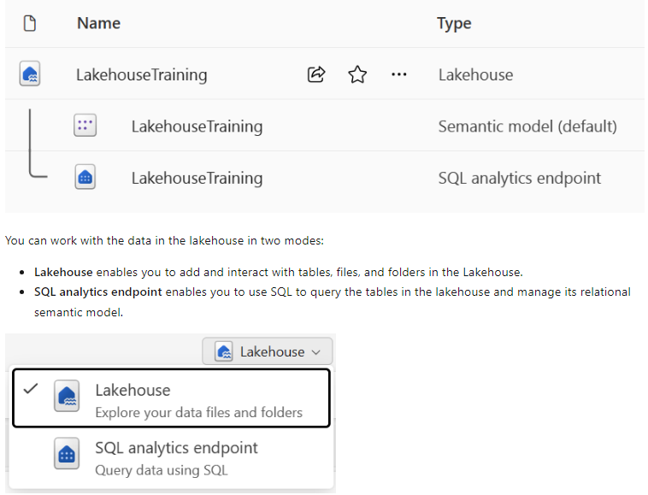

Ingest data into a lakehouse
There are many ways to load data into a Fabric lakehouse, including:
- Upload: Upload local files or folders to the lakehouse. You can then explore and process the file data, and load the results into tables.
- Dataflows (Gen2): Import and transform data from a range of sources using Power Query Online, and load it directly into a table in the lakehouse.
- Notebooks: Use notebooks in Fabric to ingest and transform data, and load it into tables or files in the lakehouse.
- Data Factory pipelines: Copy data and orchestrate data processing activities, loading the results into tables or files in the lakehouse.
Note : Another way to access and use data in Fabric is to use shortcuts. Shortcuts enable you to integrate data into your lakehouse while keeping it stored in external storage.

Practice

Ingest data until reporting using lakehouse
Create a Workspace
Check Fabric Licence
Create Lakehouse
- Add a file from Local Machine or shortcuts (connecting to external ressources)
- Change file in to table
Analyse data using T-SQL
Analyse the data model (sementic model - relational database)
Use powerQuery to do some transformations (Group by , order….)
Create PowerBi report
Conclusion
In a created WS you can see :
Your lakehouse.
- The SQL analytics endpoint for your lakehouse.
- A default semantic model for the tables in your lakehouse.
- The Item Sales Report report.

Use Apache Spark in Microsoft Fabric

Practice
Create WS
Create Lakehouse
Load files /Folder/shortcut into lake
Create Notebook
Use dataframe to output parquet files :
- explore date
- create schema (fields data types ….)
- to transform data (using aggregation, groupby)
- save data as parquet
- save data in partition mode
Use dataframe to output table :
- Create Delta table using spark
- Save data as Delta format
- Overwrite data
- Append data
- Insert date
- Update
- Use time traveling with table version (to see table data since it creation)

Implement the lakehouse medaillon architecture IN MS Fabric
https://microsoftlearning.github.io/mslearn-fabric/Instructions/Labs/03b-medallion-lakehouse.html

Structure the lakehouse (medaillon architecture bronze , silver , gold )
One on the best practice is to separate Layers using a differente WS for each one because It can enhance security, manage capacity use, and optimize cost-effectiveness.

Star modelling

Create semantic specific Model for gold layer

Monitoring Query’s

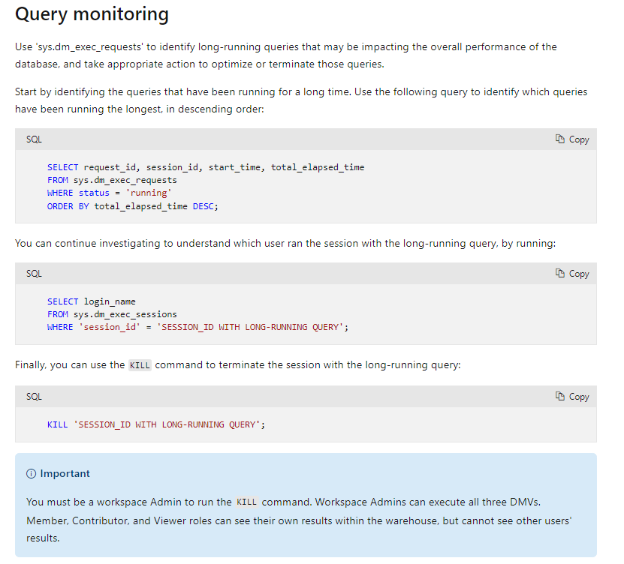

Implementation of warehouse in Fabric
https://microsoftlearning.github.io/mslearn-fabric/Instructions/Labs/06a-data-warehouse-load.html
https://learn.microsoft.com/en-us/fabric/data-warehouse/create-warehouse
This is where you create the fact and dimensions table based on received file in the Lakehouse (In Lakehouse files are in the file folder and those get transformed in managed table into table folder)
When managed table are ready , they can be use as source of the Dimension and fact tables in the warehouse. The mains steps are :
- Create tables fact and dimensions
- Create data pipeline
- Load Data to the dimension (Apply SCD type 1, 2..)

Data Activator use cases

Examen questions Example
You are working on a Microsoft Power BI report based on a Power BI semantic model that contains the following tables:
- Sales (SalesAmount,OrderDateKey,ShipDateKey)
- Date (DateKey, Date, Month, Quarter, Year)
You have connected the Date table to the Sales table on DateKey to OrderDateKey with a 1-to-many active relationship. You have connected the Date table to the Sales table on DateKey to ShipDateKey with a 1-to-many inactive relationship.
You need to create two measures that calculate Sales Amount Ordered and Sales Amount Shipped so that you can place them side-by-side in a table visual and analyze them by Year.
How should you create the measures?

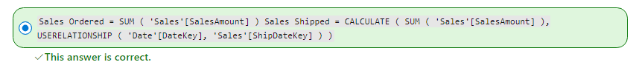

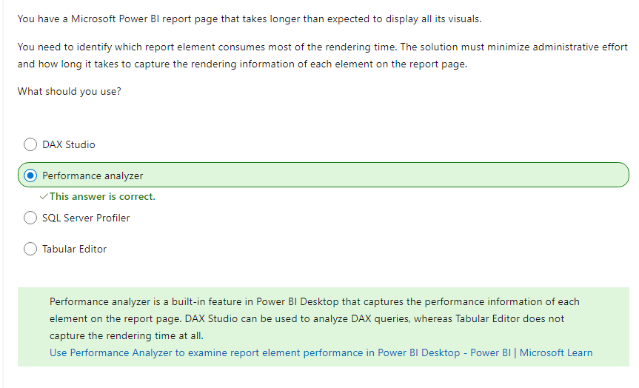

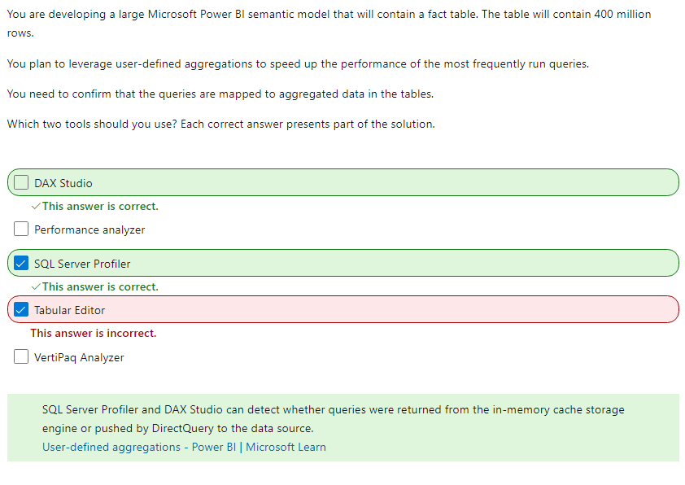
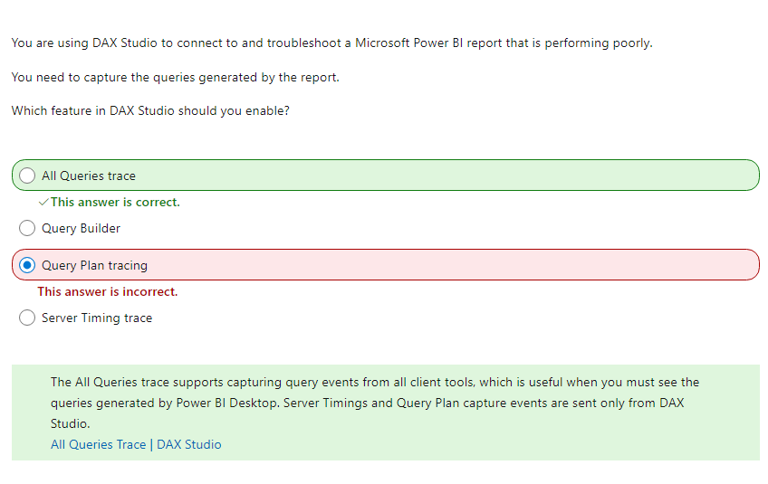

Exam questions
https://www.itexams.com/exam/DP-600

